If you are looking for information on earlier versions of AD FS, see the following articles:
ADFS in Windows Server 2012 or 2012 R2 and AD FS 2.0
Active Directory Federation Services provides access control and single sign on across a wide variety of applications including Office 365, cloud based SaaS applications, and applications on the corporate network.
- For the IT organization, it enables you to provide sign on and access control to both modern and legacy applications, on premises and in the cloud, based on the same set of credentials and policies.
- For the user, it provides seamless sign on using the same, familiar account credentials.
- For the developer, it provides an easy way to authenticate users whose identities live in the organizational directory so that you can focus your efforts on your application, not authentication or identity.
This article describes what is new in AD FS in Windows Server 2016 (AD FS 2016).

Eliminate Passwords from the Extranet
AD FS 2016 enables three new options for sign on without passwords, enabling organizations to avoid risk of network compromise from phished, leaked or stolen passwords.

Sign in with Azure Multi-factor Authentication
AD FS 2016 builds upon the multi-factor authentication (MFA) capabilities of AD FS in Windows Server 2012 R2 by allowing sign on using only an Azure MFA code, without first entering a username and password.
- With Azure MFA as the primary authentication method, the user is prompted for their username and the OTP code from the Azure Authenticator app.
- With Azure MFA as the secondary or additional authentication method, the user provides primary authentication credentials (using Windows Integrated Authentication, username and password, smart card, or user or device certificate), then sees a prompt for text, voice, or OTP based Azure MFA login.
- With the new built-in Azure MFA adapter, setup and configuration for Azure MFA with AD FS has never been simpler.
- Organizations can take advantage of Azure MFA without the need for an on premises Azure MFA server.
- Azure MFA can be configured for intranet or extranet, or as part of any access control policy.
For more information about Azure MFA with AD FS
- Configure AD FS 2016 and Azure MFA

Password-less Access from Compliant Devices
AD FS 2016 builds on previous device registration capabilities to enable sign on and access control based the device compliance status. Users can sign on using the device credential, and compliance is re-evaluated when device attributes change, so that you can always ensure policies are being enforced. This enables policies such as
- Enable Access only from devices that are managed and/or compliant
- Enable Extranet Access only from devices that are managed and/or compliant
- Require multi-factor authentication for computers that are not managed or not compliant
AD FS provides the on premises component of conditional access policies in a hybrid scenario. When you register devices with Azure AD for conditional access to cloud resources, the device identity can be used for AD FS policies as well.
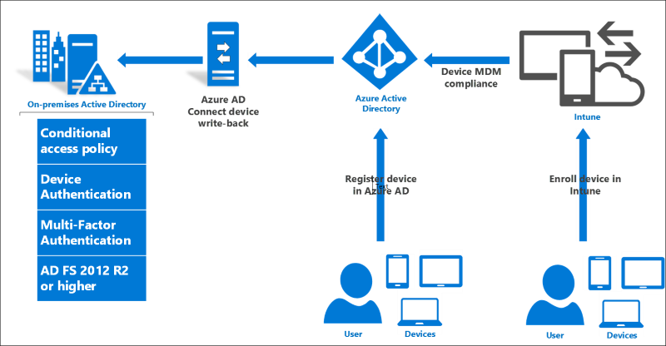
For more information about using device based conditional access in the cloud
- Azure Active Directory Conditional Access
For more information about using device based conditional access with AD FS
- Planning for Device Based Conditional Access with AD FS
- Access Control Policies in AD FS

Sign in with Microsoft Passport
Windows 10 devices introduce Windows Hello and Microsoft Passport for Work, replacing user passwords with strong device-bound user credentials protected by a user's gesture (a PIN, a biometric gesture like fingerprint, or facial recognition). AD FS 2016 supports these new these new Windows 10 capabilities so that users can sign in to AD FS applications from the intranet or the extranet without the need to provide a password.+
For more information about using Microsoft Windows Hello for Business in your organization

